8/21/23

Topic Data Science Lifecycle:

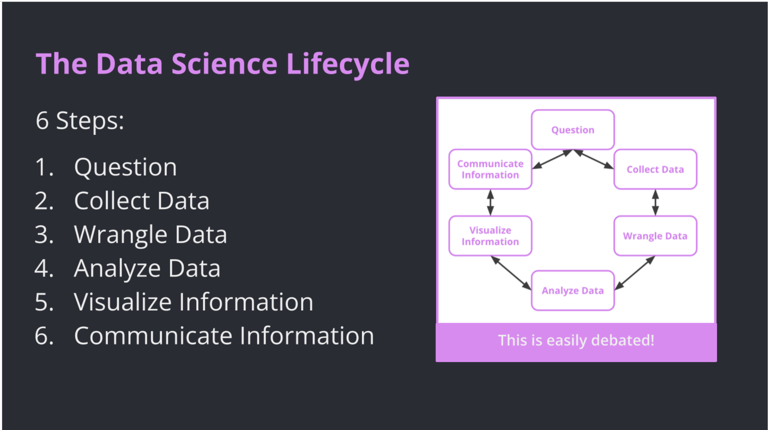

Python Fundamentals:

Data sets are collections of data: Dictionary, List, Tuple, Set etc.

Ordered, Changeable duplicates allowed

Unordered, unchangeable, duplicates not allowed

Representing Datasets with code:

Column-oriented: Grouping by features

Row-Oriented: Grouping by a single observation

Indexing:

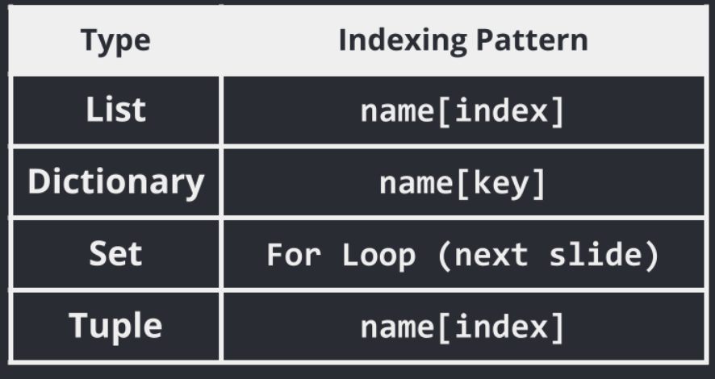

Access values = indexing

Iteration:

You can repeat processes with looks or recursion in python. Ex: While loop, For loop